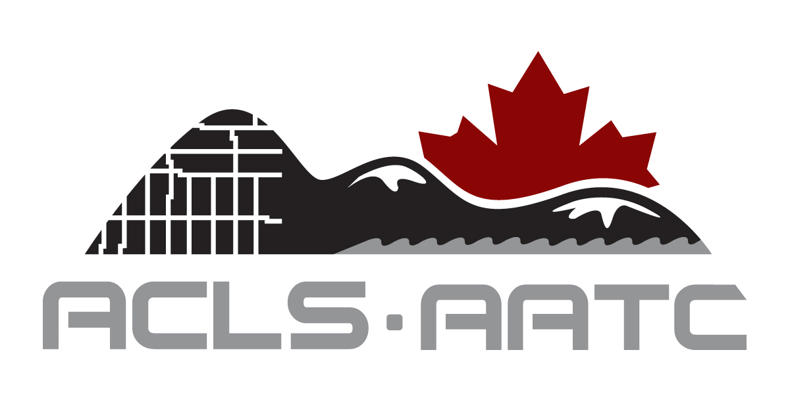

Annual ACLS CPD Travel Bursary Award

Application Form

The Annual CPD Travel Bursary Award is to be used for travel and accommodation for the event named on this form by the applicant. The maximum amount of each award is $500. Please see Award Rules and Regulations for more details.
______________________________________________________________________________
Name: Dr. Mr. Ms. Mrs.
I am applying as a new member of the ACLS Yes No
______________________________________________________________________________
Please indicate where you would like us to send correspondence:

Mailing Preference Office Residence
Correspondence English French

Office Address :
Municipality: Prov. / Terr.: Postal Code:
Tel. : Ext. : Fax :
Email : Web site:
Residence Address:
Municipality: Prov. / Terr.: Postal Code:
Tel. : Fax :
Email : Web site:
______________________________________________________________________________
Event Details:
Name of Event:
Date: City:

Name of Group(s) Organizing the Event (e.g. ACLS, OLS, CIG):

My employer/company would normally pay for all expenses related to my attendance at this event
Yes No

Estimated financial needs to attend this event:
Registration Fees: Travel:
Accommodation: Meals:
Misc.:
______________________________________________________________________________
The information provided on this form will be used solely for the purposes of processing your application.

Signature:_______________________________ Date:_________________

Please answer the following questions in the space provided below. (Alternatively, you may send in completed ACLS CPD Report Forms for at least the past two years.

In the past 5 years, have you acted as Chairperson for a Committee or Regional group for the ACLS or any Survey, Geomatics or Engineering Associations? Please provide list of Committees and dates:

In the past 5 years, other than acting as Chairperson, have you been a Committee Member for the ACLS or any Survey, Geomatics or Engineering Associations? Please provide list of Committees and dates:

List the seminars/workshops relating to Geomatics that you have attended since the beginning of last year (current calendar and the previous year).

How many ACLS AGMs have you attended in the past 5 years?

Not counting ACLS AGMs, please list the AGMs (any Geomatics Associations annual meetings) that you have attended in the past 5 years.

In the past 5 years, how many Geomatics seminars/workshops have you either organized or been a speaker for? Please provide a list.

