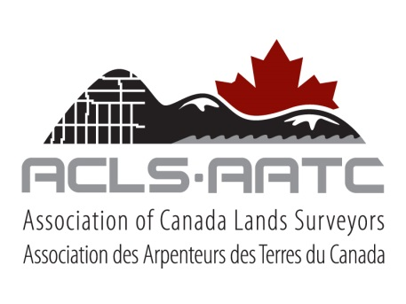

**CANADIAN HYDROGRAPHER CERTIFICATION PANEL**

**MARINE COURSES or EQUIVALENTS**

The Candidate shall provide the documentation to show the training provided by the marine courses on the CHCP Application Checklist, or their equivalent to one or more of those marine courses, has been obtained.

* **Innovation, Science and Economic Development Canada – Restricted Operator’s Certificate (Maritime) – ROC(M)**

**Objectives**

This certificate is mainly intended for pleasure boaters, as they do not fall within the scope of Transport Canada’s Ship Station (Radio) Regulations, 1999. As of September 1, 2000, Industry Canada delegated the examination and administration of the ROC-M certification program to Canadian Power and Sail Squadrons (CPS). Courses for this certificate are developed and delivered by private examiners and/or instructors associated with CPS. Application for this certificate can be obtained from CPS, and certificates are issued by CPS. Certificates are valid for life and there is no renewal requirement. No photograph of the holder is required, and there is no age or nationality restriction.

Source: Innovation, Science and Economic Development Canada; Internet, Radio, and Wireless; Spectrum Management and Communications; RIC 16 – Professional Radio Operator Certificates at <http://www.ic.gc.ca/eic/site/smt-gst.nsf/eng/sf01014.html> (last accessed: 12 September 2018).

The CPS Maritime Radio course teaches emergency radio procedures and everyday operating techniques. Learn all about the uses of marine radios, choice of frequencies, operation, phonetic alphabet, procedural words and phrases, as well as Digital Selective Calling and the Global Maritime Distress and Safety System, (DSC/GMDSS).

Source: Canadian Power and Sail Squadrons; VHF Marine Radio Course; Get the Certificate; Marine Radio Course at <http://www.boatingcourses.ca/course-descriptions/maritime-radio-0> (last accessed: 12 September 2018).

**Equivalency**

Candidate’s explanation.

* **Transport Canada – Marine Emergency Duties: MED A1 or MED A3**

**MED A1 and A3**

MED A1 refers to Basic Safety whilst MED A3 refers to a course providing basic safety training for crew members of non-pleasure vessels of not more than 150 gross tonnage operating not more than 25 nautical miles from shore, both of which have been aligned with STCW.

Source: Transport Canada, Marine Safety, Marine Emergency Duties, Training Courses – TP 4957 E at <http://www.tc.gc.ca/publications/en/tp4957/pdf/hr/tp4957e.pdf> (last accessed 12 September 2018) page 14 and 32 respectively.

**MED A1 and A3 - Goals**

1) Provide seafarers with a basic understanding of the hazards associated with the marine environment and their own vessel, and of how to prevent shipboard incidents including fire.

2) Provide seafarers with the knowledge necessary to raise and react to alarms and deal with emergencies.

3) Ensure that seafarers are able to provide assistance in fire and abandonment situations.

4) Provide seafarers with the knowledge and skills that will enable them to assist in their own survival and rescue.

Source: *Ibid*, pages 15 and 33 respectively.

**Equivalency**

Candidate’s explanation.

* **Transport Canada – Small Vessel Operator Proficiency (SVOP)**

**Objectives**

Provide the minimum training of operators of commercial vessels, other than tugs and fishing vessels, up to 5 gross tonnage engaged on a near coastal, class 2 or a sheltered waters voyage, and for fishing vessels up to 15 gross tonnage or 12 meters overall length engaged on a near coastal, class 2 (including an inland voyage on Lake Superior or Lake Huron) or a sheltered waters voyage.

**Goals**

1. A basic understanding of the hazards associated with the marine environment and their own vessel and the prevention of shipboard incidents.
2. The knowledge and skills necessary to safely operate a small non-pleasure vessel in near coastal and sheltered waters under normal operating conditions, including darkness and restricted visibility.
3. Additional knowledge on aids to navigation and seamanship to supplement individual experience.

Source: Transport Canada; Marine Transportation; Marine Safety; Marine Safety Publications; Small Vessel Operator Proficiency Training Course - TP 14692 E at <https://www.tc.gc.ca/eng/marinesafety/tp-tp14692-menu-1373.htm> (last accessed 12 September 2018)

**Equivalency**

Candidate’s explanation.