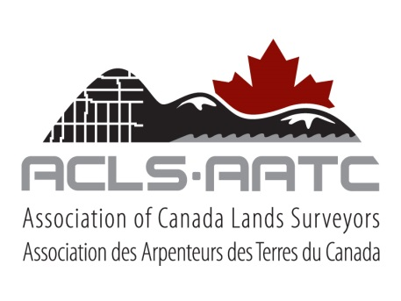

**CANADIAN HYDROGRAPHER CERTIFICATION PANEL**

**CANDIDATE APPLICATION – FORM**

Surname: _____________________________  Dr.  Mr.  Ms.  Mrs.

First Name: ____________________________

I am currently a regular member of the ACLS  Yes  No

Please provide an Office or Residence address  Office  Residence

Company Name (if applicable):

Address:

City or Town: Prov. / Terr. / State:

Postal or Zip Code: Country: Tel: Ext.: _____

Email:

I am applying as the following type of candidate:

Level 1

Category A

Category B

Holder of CLS Commission Number

Other (please specify)

Level 2

Category B

Other (please specify)

**Please send this form, along with all required information (see attached checklist) and the applicable candidate registration fee. (CAD $ 325.00 for ACLS Regular Members or CAD $ 500 for others), Please indicate method of payment:**

Cheque enclosed  MasterCard  Visa

Card Number _______________________________Expiry Date _____________________

……………………………………....................... .....................................................

Signature Date